Market Basket Insights

PHASE : 2

SUBMITTED BY:

Athirala Ganesh,

au723921243003,

athiralaganesh004@gmail.com

**INNOVATION:**

Advanced association analysis techniques and the use of visualization tools can significantly enhance insights presentation and innovation in various fields. Here are some ways in which these techniques can be applied

**INNOVATION STEPS:**

1. **Retail and Market Basket Analysis:**
   * Retailers can use advanced association analysis techniques to identify patterns in customer purchases. By understanding which products are frequently bought together, they can optimize store layouts and promotions.
   * Visualization tools like heatmaps or network diagrams can help present these associations in a visually appealing and understandable way.
2. **Healthcare and Disease Analysis:**

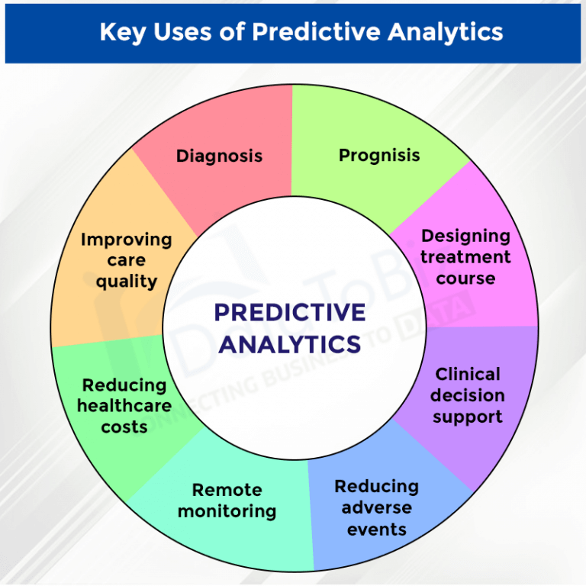

* + In healthcare, association analysis can help identify relationships between patient attributes and disease outcomes. This can lead to more personalized treatment plans.
  + Visualization tools can be used to create interactive dashboards that allow healthcare professionals to explore patient data and associations visually.

1. **Social Network Analysis:**
   * Social network analysis often involves identifying associations and connections between individuals. Advanced techniques can uncover hidden relationships, potentially leading to innovative approaches in marketing, influence analysis, or public health.

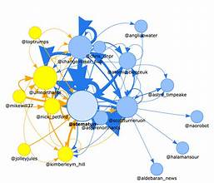

* + Visualization tools can create dynamic network graphs and influence maps that provide a clear view of the network structure.

1. **Recommendation Systems:**
   * E-commerce platforms and content providers use association analysis to make personalized recommendations to users. Advanced techniques, such as collaborative filtering or matrix factorization, can improve recommendation accuracy.
   * Visualization can help users understand why specific recommendations are made, fostering trust and encouraging them to explore new products or content.
2. **Supply Chain Optimization:**
   * Advanced association analysis techniques can identify relationships between different elements of the supply chain, such as demand patterns, inventory levels, and supplier performance.
   * Visualization tools can create supply chain maps and real-time dashboards, making it easier to identify bottlenecks and optimize processes.
3. **Research and Innovation in Scientific Fields:**
   * In scientific research, advanced association analysis can reveal hidden connections between various data points, leading to discoveries and innovations in fields such as genomics, materials science, and pharmaceuticals.
   * Visualization tools can help researchers explore complex data sets and identify patterns or correlations that may not be apparent through traditional statistical methods.
4. **Fraud Detection and Anomaly Detection:**
   * Advanced association analysis can be used to identify unusual patterns in financial transactions or system logs that may indicate fraud or security breaches.
   * Visualization tools can create real-time dashboards for security analysts to monitor and respond to anomalies.
5. **Smart Cities and IoT Data Analysis:**
   * In smart cities and IoT applications, association analysis can help uncover patterns in sensor data, traffic flows, and energy consumption.



* + Visualization tools can provide city planners and policymakers with insights into optimizing infrastructure and improving the quality of life for residents.

Incorporating advanced association analysis techniques and visualization tools can lead to more informed decision-making, innovative solutions, and improved understanding of complex data. These techniques are particularly valuable in today's data-driven world, where making sense of large and complex datasets is essential for driving progress and innovation.